CREDIT CARD FRAUD DETECTION USING MACHINE LEARNING

Project Report

Viswadharini Navamani

S.No | Title | P.No
 | Abstract
1. | Introduction
2. | Objectives
3. | Dataset Description
4. | Methodology
5. | EDA Findings
6. | Model Development & Performance
7. | Interpretation of Model Results & Top Fraud Predictors
8. | Power BI Dashboard
9. | Fraud Detection Interface
10. | Conclusion
11. | Future Scope
12. | References

ABSTRACT
Credit card fraud is a major challenge in the financial sector, resulting in significant financial losses and affecting customer trust. This project focuses on developing a machine learning-based system for detecting fraudulent credit card transactions. The dataset contains transaction-related features, including Time, Amount, and anonymized variables (V1–V28), along with the Class variable representing legitimate and fraudulent transactions.
The project follows a systematic process involving data preprocessing, exploratory data analysis (EDA), feature scaling, handling of class imbalance, and machine learning model development. Logistic Regression with balanced class weights was implemented to improve the detection of fraudulent transactions. Model performance was evaluated using appropriate classification metrics, with particular attention to fraud detection capability. The model was also interpreted to identify the transaction features that have the greatest influence on fraud predictions.
In addition, an interactive Power BI dashboard was developed to visualize transaction patterns, fraud distribution, transaction amounts, fraud rates, and other important trends. The final system provides both predictive and visual analytical capabilities that can help identify potentially fraudulent transactions and support data-driven decision-making.

1. INTRODUCTION
Credit card fraud is one of the major challenges faced by the financial industry. With the increasing use of online transactions and digital payment systems, the number of electronic transactions has grown significantly. This has also created opportunities for fraudulent activities, making reliable fraud detection systems increasingly important.
Traditional rule-based fraud detection methods may not always be effective because fraudulent transaction patterns can change over time. Machine learning provides a data-driven approach that can learn patterns from historical transaction data and identify transactions that have characteristics similar to previously observed fraudulent transactions.This project focuses on developing a machine learning-based credit card fraud detection system using transaction data. The dataset contains numerical transaction features, including Time, Amount, and anonymized variables V1 to V28, along with a Class variable indicating whether a transaction is legitimate or fraudulent.
The project involves data preprocessing, exploratory data analysis (EDA), feature scaling, handling the imbalanced nature of the dataset, and developing a Logistic Regression classification model. The model is evaluated using classification metrics to understand its ability to distinguish fraudulent transactions from legitimate ones.In addition to the machine learning model, a Power BI dashboard is developed to provide an interactive view of transaction patterns, fraud distribution, transaction amounts, fraud rates, and other important trends. The combination of predictive odelling and visualization provides a practical approach to understanding and detecting credit card fraud.
2. OBJECTIVES
To analyze credit card transaction data and understand the characteristics and distribution of legitimate and fraudulent transactions.

To perform data preprocessing including data cleaning, feature scaling, and preparation of the dataset for machine learning.

To handle the class imbalance problem because fraudulent transactions represent only a small proportion of the overall transactions.

To develop a machine learning model using Logistic Regression to classify transactions as legitimate or fraudulent.

To evaluate model performance using suitable classification metrics and assess its ability to detect fraudulent transactions.

To interpret the model results and identify the top transaction features that contribute to fraud predictions.

To develop an interactive Power BI dashboard that presents fraud trends, transaction patterns, fraud rates, and high-risk segments.

To provide useful insights that can support better monitoring and identification of potentially fraudulent credit card transactions.

3. DATASET DESCRIPTION
The dataset used in this project is a credit card transaction dataset designed for fraud detection. It contains transaction-level information with numerical features that describe different characteristics of each transaction.
The dataset consists of 30 input features, including Time, V1 to V28, and Amount. The features V1 to V28 are anonymized numerical variables. The Class variable is the target variable used to identify whether a transaction is legitimate or fraudulent.
The target variable Class contains two categories:
- 0 – Legitimate transaction
- 1 – Fraudulent transaction
The dataset is highly imbalanced because fraudulent transactions form only a small proportion of the total transactions. Therefore, class imbalance was considered during the model development process. The data was prepared for machine learning through preprocessing and feature scaling before training the classification model.

The dataset was divided into training, validation, and testing subsets. The training data was used to build the Logistic Regression model, while the validation data was used for model evaluation and threshold-related analysis. The final testing data was kept for assessing the model's performance on unseen transactions.
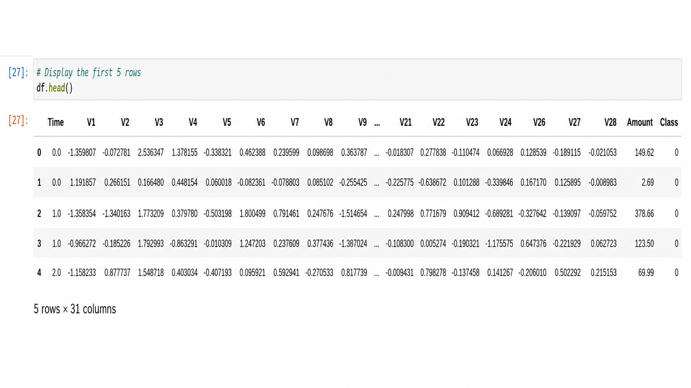
Figure 3.1 Dataset Preview – First Five Rows

4. METHODOLOGY
The project follows a systematic machine learning workflow for detecting fraudulent credit card transactions. The methodology consists of data preparation, exploratory data analysis, preprocessing, model development, model evaluation, interpretation, and visualization.
4.1 Data Preprocessing
The transaction dataset was examined to understand its structure, features, data types, and target variable. The input features were separated from the target variable, where Class represents whether a transaction is legitimate or fraudulent. The numerical features were prepared for machine learning, and feature scaling was performed to bring the variables to a comparable scale.
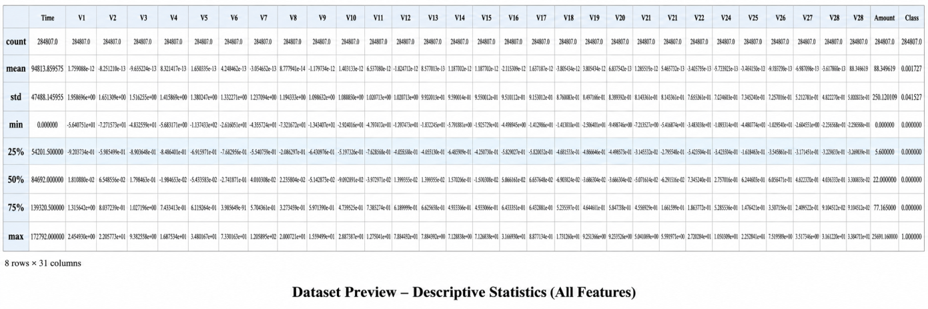
Figure 4.1.1 Dataset Processing Preview
4.2 Exploratory Data Analysis
Exploratory Data Analysis (EDA) was performed to understand transaction distributions and identify patterns associated with fraudulent transactions. The analysis included examining the class distribution, transaction amounts, transaction timing, and relationships between transaction features and the fraud class.
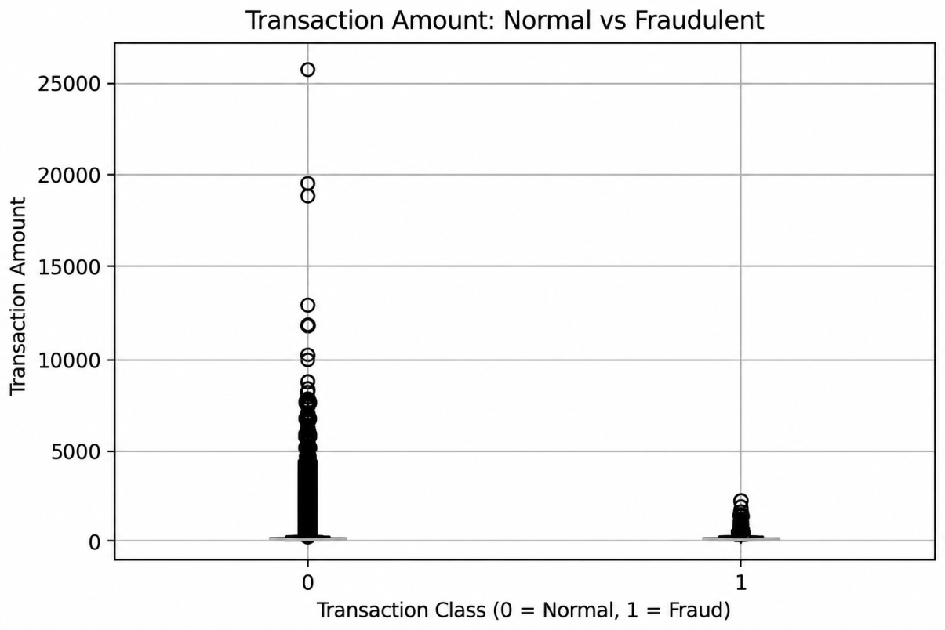
Figure 4.2.1 Transaction Amount in EDA
4.3 Handling Class Imbalance
The dataset contains significantly fewer fraudulent transactions than legitimate transactions. To address this class imbalance during model training, balanced class weights were used in the Logistic Regression model. This gives greater importance to the minority fraud class and helps the model pay more attention to fraudulent transactions.
4.4 Model Development
A Logistic Regression classification model was selected for fraud detection. The model was trained using the prepared and scaled training data. The model estimates the probability that a transaction belongs to the fraudulent class and uses this probability to classify transactions.
4.5 Model Evaluation
The model was evaluated using classification performance measures, with particular attention to its ability to identify fraudulent transactions. Validation data was used to assess the model and analyze fraud probabilities before evaluating the final model on unseen test data.
4.6 Model Interpretation
The coefficients generated by the Logistic Regression model were analyzed to identify the features that have the greatest influence on fraud predictions. The absolute coefficient values were used to rank the top predictors of fraud.
4.7 Power BI Visualization
A Power BI dashboard was created to present important findings from the transaction dataset. The dashboard includes visualizations of transaction counts, fraud rate, transaction amounts, fraud trends over time, and comparisons between legitimate and fraudulent transactions.
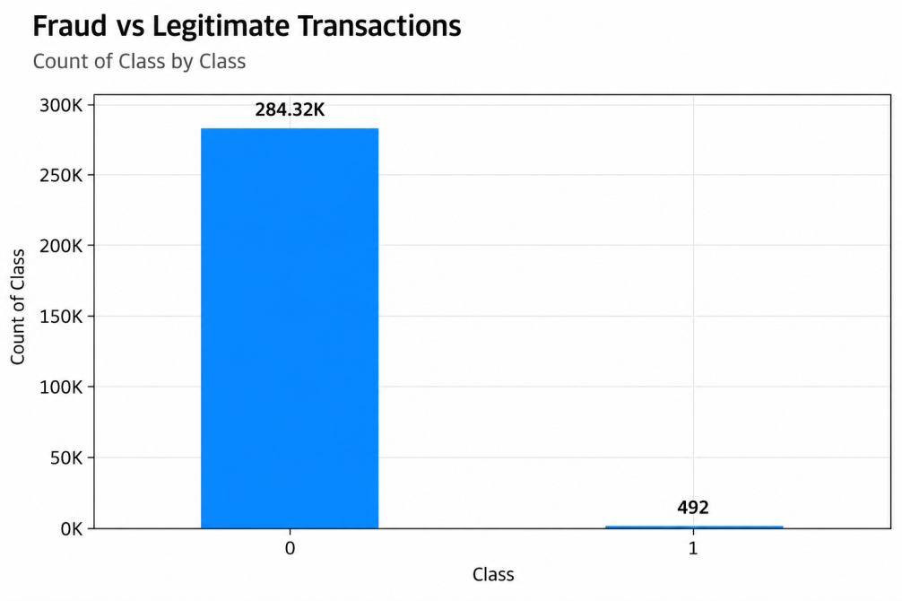
Figure 4.7.1 Fraud vs Legitimate Transactions
5. EDA FINDINGS
Exploratory Data Analysis (EDA) was performed to understand the structure of the credit card transaction dataset and identify patterns associated with fraudulent transactions. The analysis focused on the target-class distribution, transaction amounts, transaction timing, and differences between legitimate and fraudulent transactions.
5.1 Class Distribution
The dataset contains 284,807 transactions. Among these, 284,315 transactions (99.8273%) are legitimate, while only 492 transactions (0.1727%) are fraudulent. This demonstrates a severe class imbalance, with fraudulent transactions representing a very small proportion of all transactions. This imbalance is an important consideration when developing and evaluating the fraud detection model.
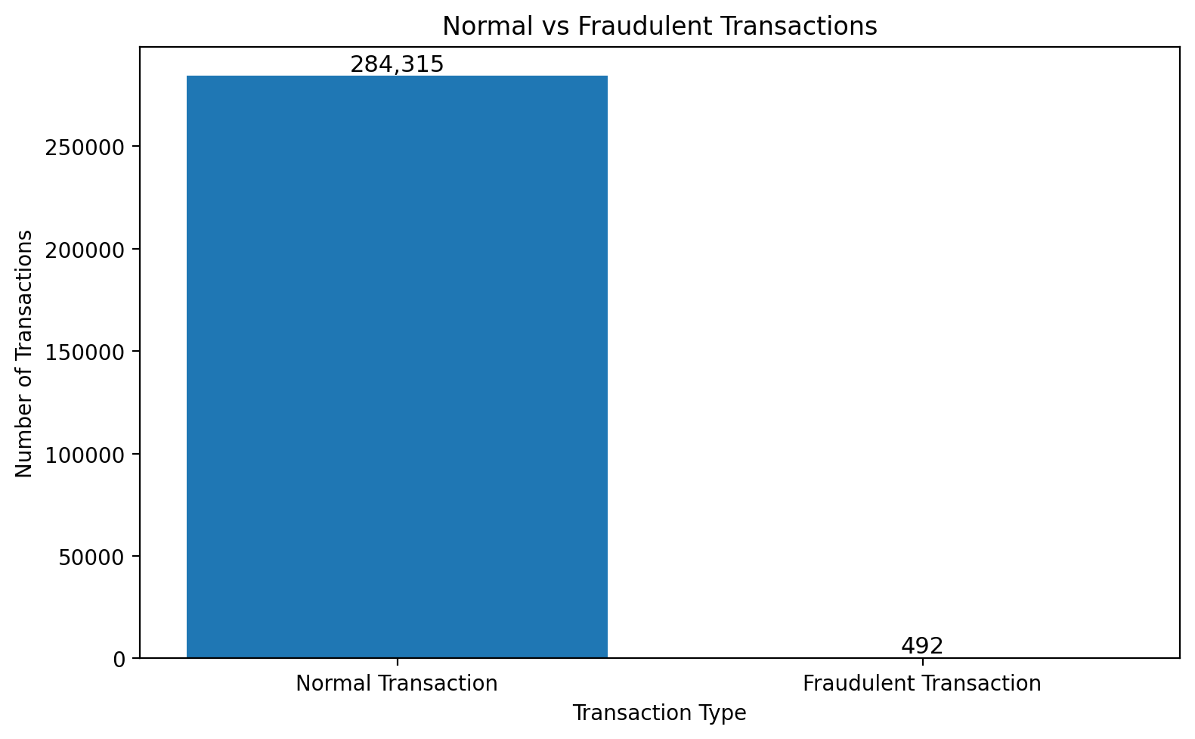
Figure 5.1.1 Normal vs Fraudulent Transactions
5.2 Data Quality
The initial data inspection showed that the dataset did not contain missing values. During data cleaning, 1,081 duplicate records were identified and removed. After removing the duplicates, the dataset contained 283,726 unique transactions. This preprocessing step helped ensure that repeated records did not unnecessarily influence the analysis and model.
5.3 Transaction Amount
Transaction amount was analyzed to understand whether the monetary value of transactions differed between legitimate and fraudulent transactions. The analysis showed that fraudulent transactions had a higher average transaction amount than legitimate transactions in the analyzed data. In the Power BI dashboard, the average transaction amount was approximately $120 for fraudulent transactions compared with approximately $88 for legitimate transactions.
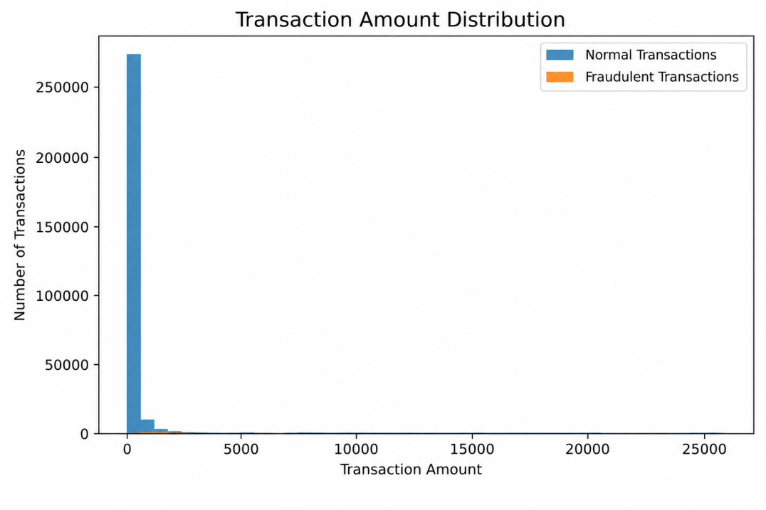
Figure 5.3.1 Transaction Amount Distribution
5.4 Transaction Time
Transaction timing was also examined to identify changes in transaction activity and fraud patterns across time. The time-based analysis provides a way to observe periods where fraudulent activity may differ from normal transaction activity and supports further investigation of potentially high-risk periods.
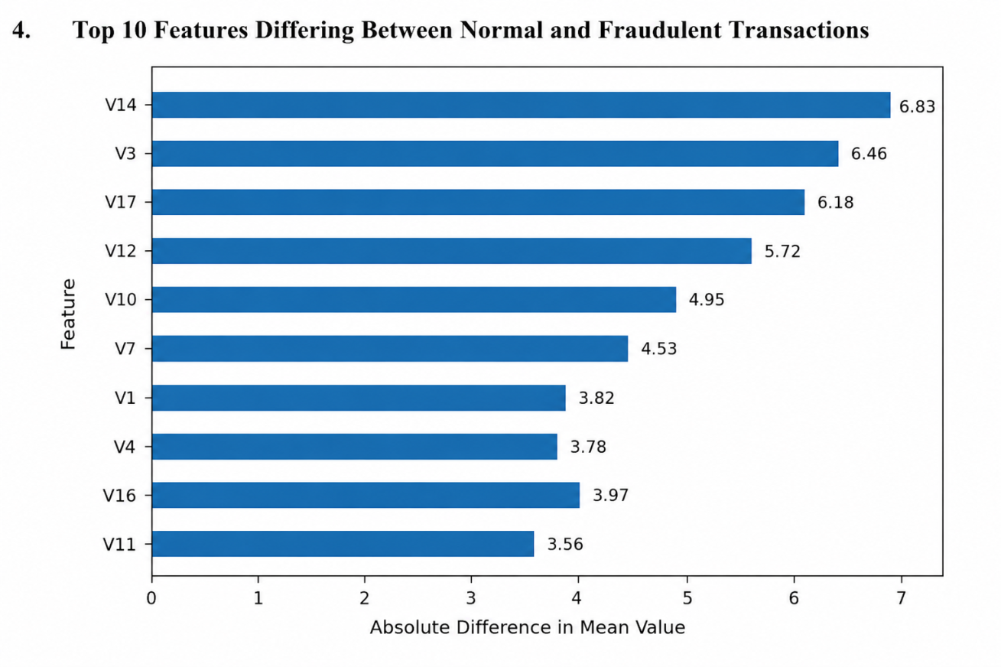
Figure 5.4.1 Top 10 Features Differing Between Normal and Fraudulent Transactions

5.5 Key EDA Insights
The EDA identified three important characteristics of the dataset. First, fraudulent transactions form a very small minority of all transactions, creating a significant class imbalance. Second, transaction amount shows a difference between fraudulent and legitimate transactions. Third, transaction timing can be used to explore patterns in fraud activity. These findings guided the subsequent preprocessing, model development, and dashboard design.
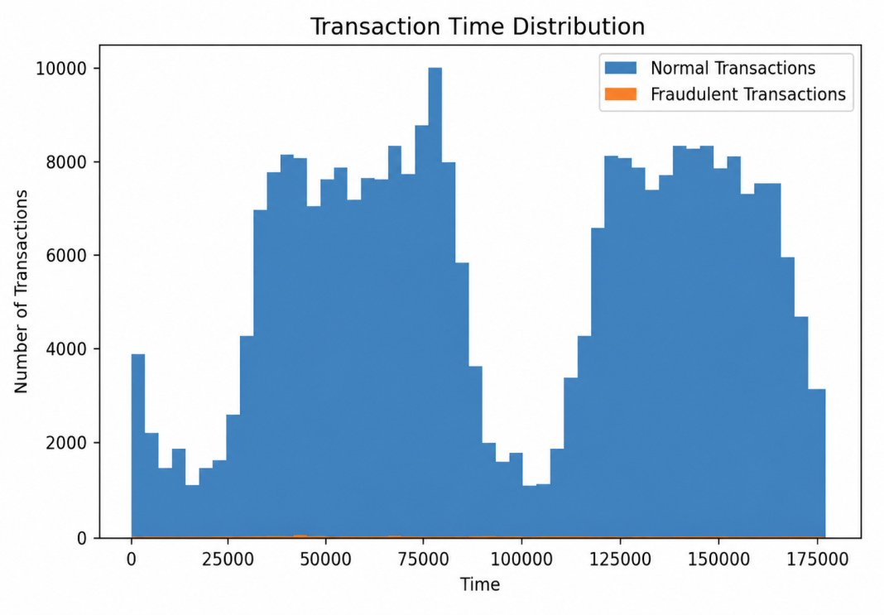
Figure 5.5.1 Transaction Time Distribution of Normal and Fraudulent Transactions

6. MODEL DEVELOPMENT & PERFORMANCE
6.1 Model Selection
Logistic Regression was selected as the classification algorithm for this project. It is a supervised learning algorithm suitable for binary classification problems such as distinguishing between legitimate and fraudulent transactions. It also provides interpretable coefficients, which can be used to identify the features that have the greatest influence on fraud predictions.
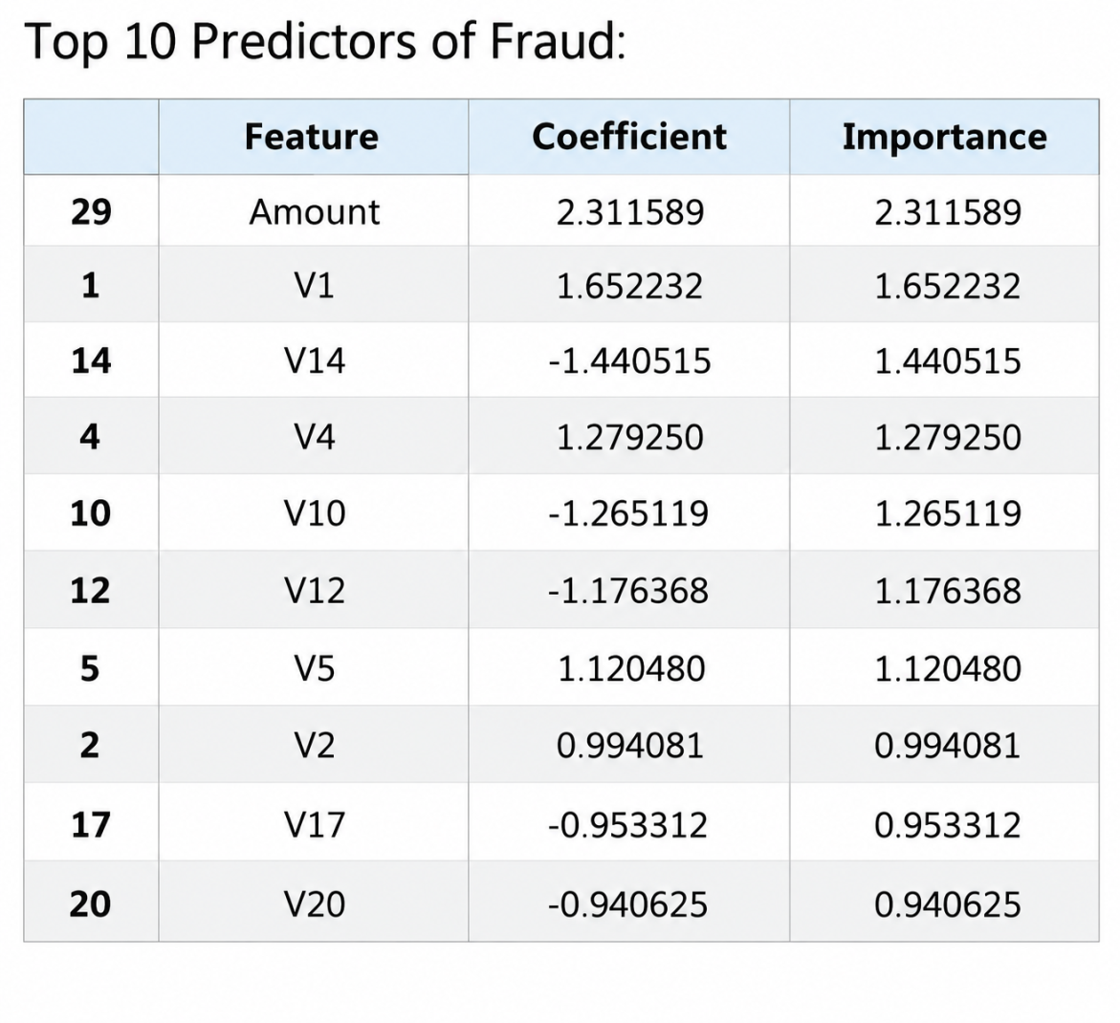
Figure 6.1.1 Logistic Regression of Top 10 Predictors of Fraud

6.2 Feature Scaling
Feature scaling was performed using StandardScaler. Scaling transforms the numerical input variables to a comparable scale, which is particularly important for Logistic Regression because the model's coefficients are influenced by the scale of the input features.
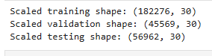
Figure 6.2.1 The StandardScaler of Logistic Regression
6.3 Handling Class Imbalance
The dataset is highly imbalanced, with fraudulent transactions representing only a small percentage of the total transactions. To reduce the effect of this imbalance during training, the Logistic Regression model was configured with class_weight='balanced'. This assigns greater weight to the minority fraud class and helps the model identify fraudulent transactions more effectively.
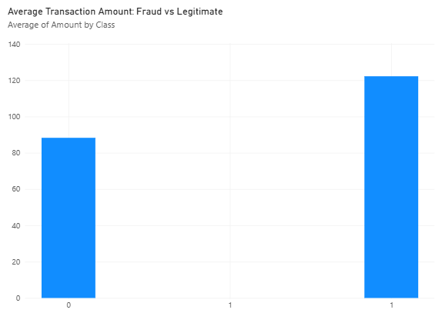
Figure 6.3.1 Class weight Balancing with Fraud vs Legitimate
6.4 Model Training
The preprocessed dataset was divided into training and testing data. The Logistic Regression model was trained using the scaled training features and the corresponding class labels. After training, the model generated fraud probabilities and class predictions for previously unseen transactions.
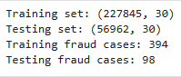
Figure 6.4.1 The Training and Testing of Preporcessed Dataset

6.5 Model Performance
The model achieved a ROC-AUC score of 0.9737, approximately 0.974, on the test data. ROC-AUC measures the model's ability to distinguish between fraudulent and legitimate transactions across different classification thresholds. A value close to 1 indicates strong discriminatory performance.
 | Predicted Legitimate | Predicted Fraud
Actual Legitimate | 56,842 | 22
Actual Fraud | 18 | 80
Table 6.5.1 The confusion matrix obtained from the test data

The model correctly identified 80 fraudulent transactions and incorrectly classified 18 fraudulent transactions as legitimate. It also incorrectly classified 22 legitimate transactions as fraudulent. These results demonstrate that the model was able to detect a substantial proportion of fraudulent transactions while keeping false positives relatively low.
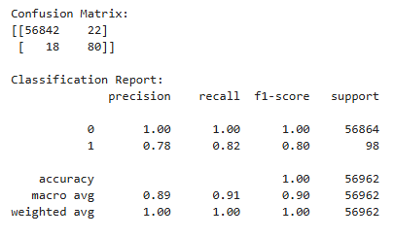
Figure 6.5.1 The Confusion Matrix and Classification Report
6.6 Model Evaluation Summary
Overall, the Logistic Regression model demonstrated strong ability to separate fraudulent transactions from legitimate transactions, as reflected by the ROC-AUC score of 0.9737. The use of balanced class weights was important because of the severe class imbalance in the dataset. The confusion matrix also provides a clearer understanding of the model's fraud-detection performance.
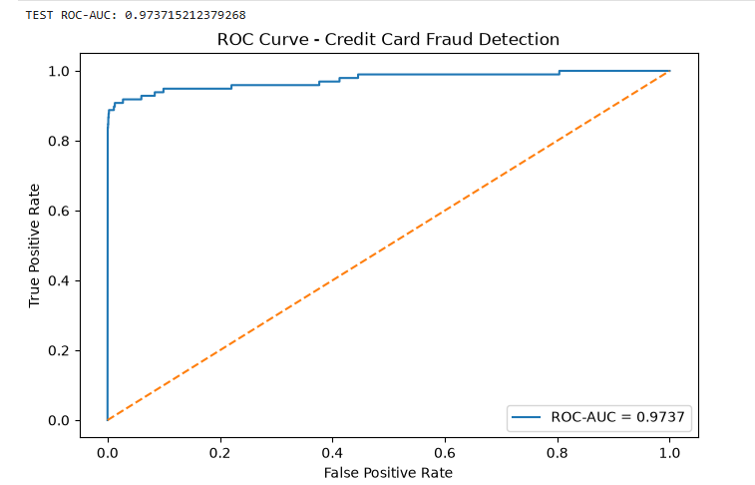
Figure 6.6.1 ROC Curve – Credit Card Fraud Detection
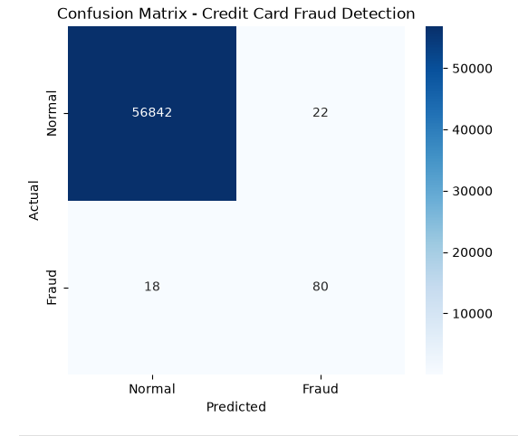
Figure 6.6.2 Confusion matrix Graph
7. Interpretation of Model Results
The Logistic Regression model was interpreted using the magnitude and direction of its feature coefficients. The absolute value of each coefficient was used to determine the relative importance of the corresponding feature in distinguishing fraudulent transactions from legitimate transactions. The analysis identified Amount as the most influential predictor, followed by V1, V14, V4, V10, V12, V5, V2, V17, and V20.
The Amount feature had the highest importance with a coefficient of 2.311589, indicating that transaction amount had a strong influence on the model's fraud prediction. V1 and V4 also had positive coefficients, while V14, V10, V12, V17, and V20 had negative coefficients. In Logistic Regression, the coefficient sign indicates the direction of the feature's association with the predicted class, while the coefficient magnitude indicates its relative influence on the model's decision.
These results show that fraud detection is influenced by a combination of transaction amount and the anonymized transaction features. Since the V1–V28 variables are anonymized features in the dataset, their individual real-world meanings cannot be directly interpreted. However, their coefficients provide useful information about which variables contribute most strongly to the model's fraud classification.

Rank | Feature | Coefficient | Importance
1 | Amount | 2.311589 | 2.311589
2 | V1 | 1.652232 | 1.652232
3 | V14 | -1.440515 | 1.440515
4 | V4 | 1.279250 | 1.279250
5 | V10 | -1.265119 | 1.265119
6 | V12 | -1.176368 | 1.176368
7 | V5 | 1.120480 | 1.120480
8 | V2 | 0.994081 | 0.994081
9 | V17 | -0.953312 | 0.953312
10 | V20 | -0.940625 | 0.940625
Table 7.1 Top 10 predictors of fraud

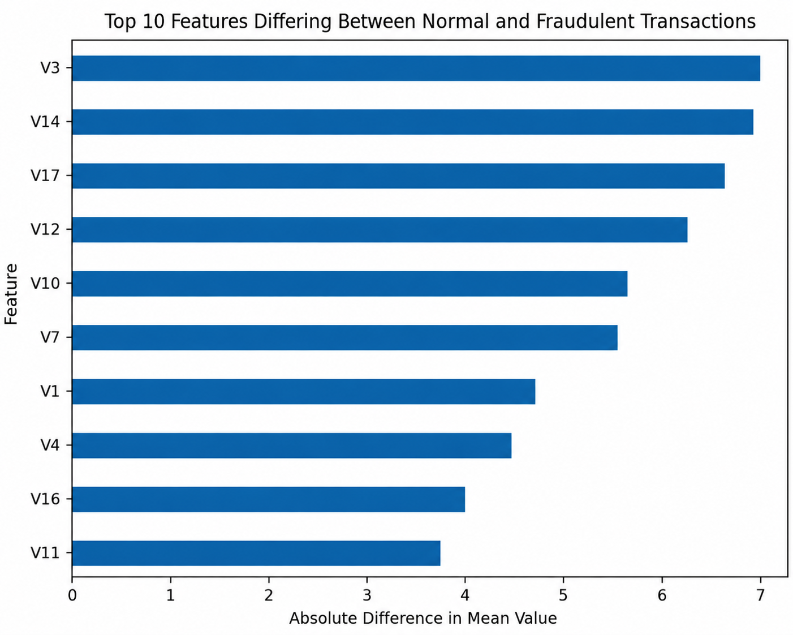
Figure 7.1 Features Differing Between Normal and Fraudulent Transactions

7.1 Top Fraud Predictors
The model identified several features that had a strong influence on distinguishing fraudulent transactions from normal transactions. The most important predictors included Amount, V1, V14, V4, V10, V12, V5, V2, V17, and V20. These features showed the largest absolute differences or coefficients and therefore contributed significantly to the model's fraud-detection decisions.
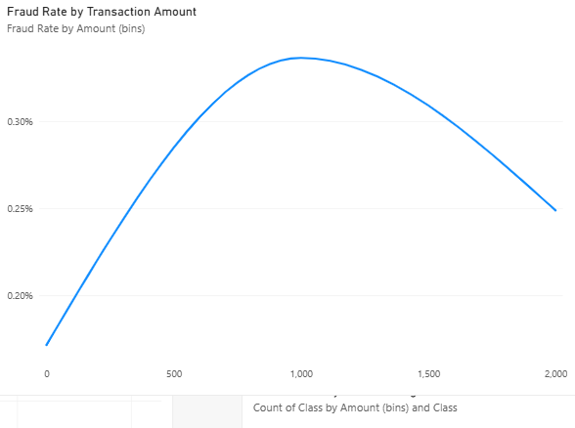
Figure 7.1.1 Top Fraud Predictors of Transaction Amount

8. Power BI Dashboard
The Power BI dashboard provides an interactive visual summary of the fraud detection analysis. It presents key transaction statistics, class distribution, model performance, and important fraud-related patterns, helping users understand the results and derive useful business insights.
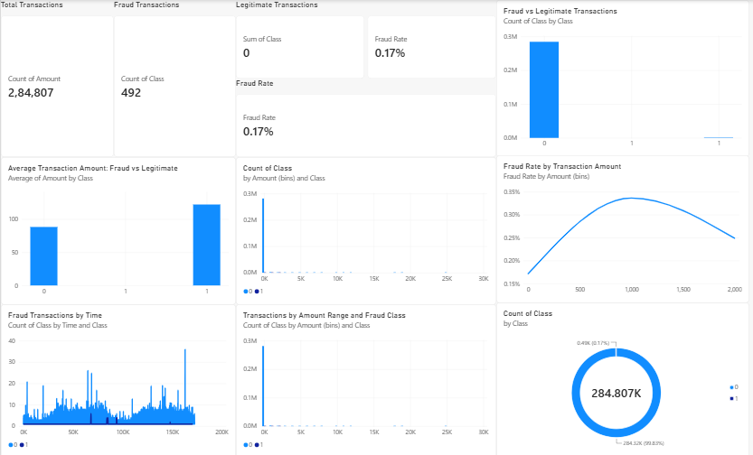
Figure 8.1 Power BI Dashboard

9. Fraud Detection Interface
A user-friendly fraud detection interface was developed using Gradio to demonstrate the practical application of the trained Logistic Regression model. The interface allows users to enter the transaction features, including Time, V1–V28, and Amount. The trained model processes the input and predicts whether the transaction is legitimate or fraudulent, along with the corresponding fraud probability. This interface provides a simple way to demonstrate how the developed fraud detection model can be used for individual transaction prediction.
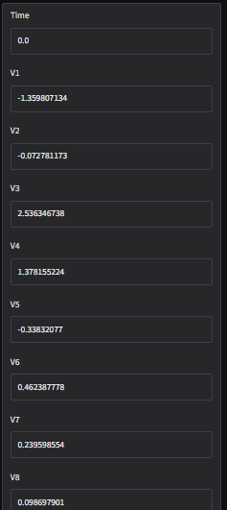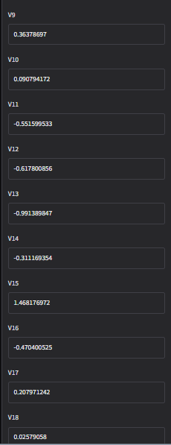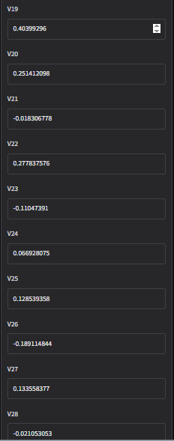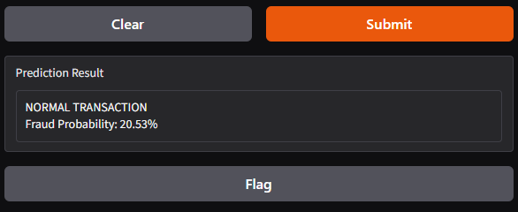
Figure 9.1 Normal Transaction Prediction Using the Fraud Detection Interface
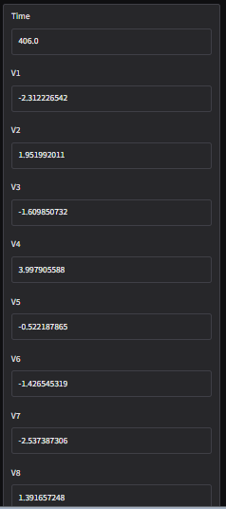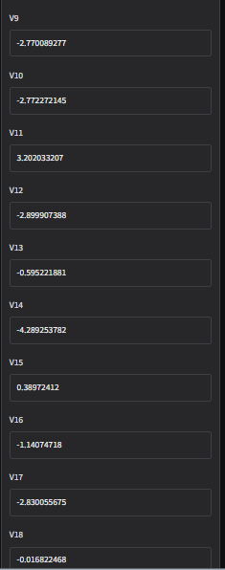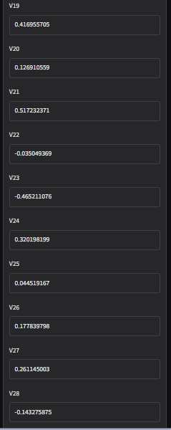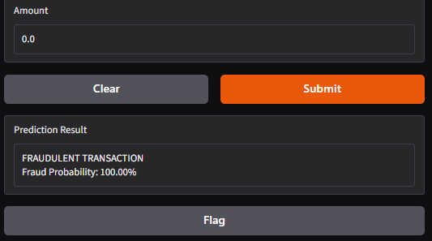
Figure 9.2 Fraudulent Transaction Prediction Using the Fraud Detection Interface

10. Conclusion
This project developed a machine learning-based credit card fraud detection system to identify potentially fraudulent transactions. The analysis showed a severe imbalance between legitimate and fraudulent transactions, making appropriate evaluation metrics and class balancing important. The developed model achieved a ROC-AUC score of approximately 0.9737, demonstrating strong capability in distinguishing fraudulent transactions from legitimate ones. The confusion matrix and other performance metrics further helped evaluate the model's effectiveness. The identification of important fraud predictors also provided useful insights into the factors contributing to fraudulent transaction detection.
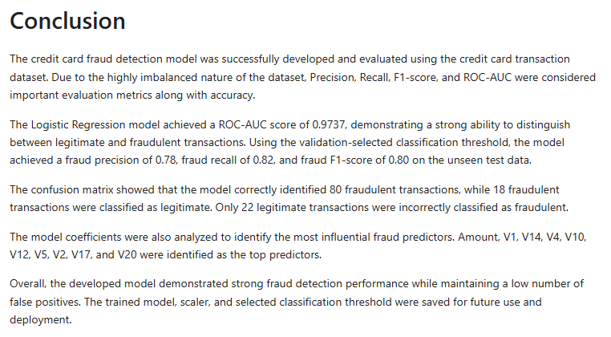
Figure 10.1 Conclusion

11. Future Scope
The fraud detection system can be further improved by evaluating additional machine learning and deep learning algorithms and comparing their performance. Real-time transaction monitoring could also be incorporated to detect suspicious transactions immediately. Future work could include advanced anomaly-detection techniques, continuous model retraining with new transaction data, threshold optimization, and deployment of the model as a production-level fraud detection application. Integration with interactive dashboards and user-friendly interfaces can further support practical decision-making.

12. References
Kaggle — Credit Card Fraud Detection Dataset.
Scikit-learn — Machine Learning and Model Evaluation Documentation.
Pandas — Python Data Analysis Library.
Matplotlib — Python Visualization Library.
Microsoft Power BI Documentation.
Gradio Documentation.

